Creating a new package/file/class

In this example is the EngineDisplay class a new file

1: right click on the new class

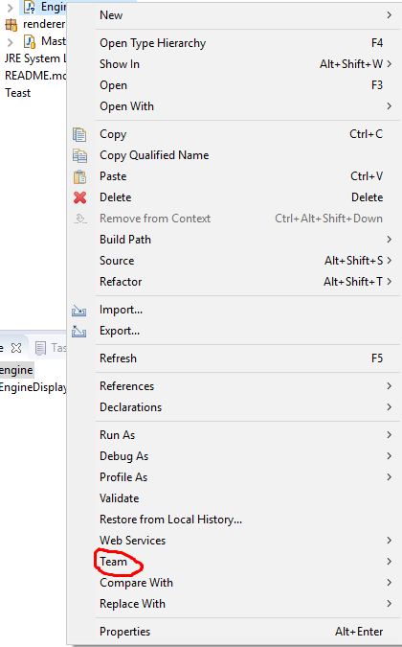

2: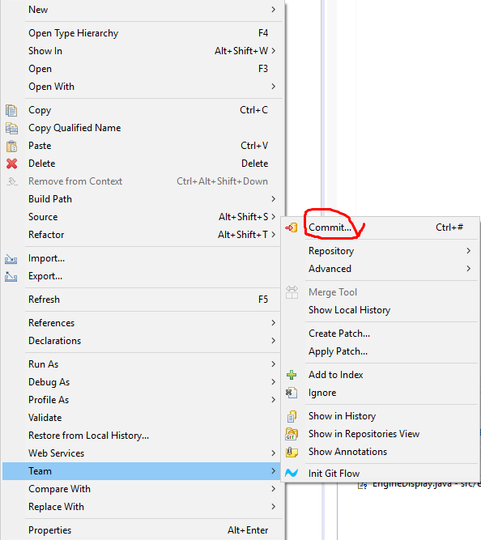

3: It will open a new tab somewhere and with this window and drag the class to staged changes

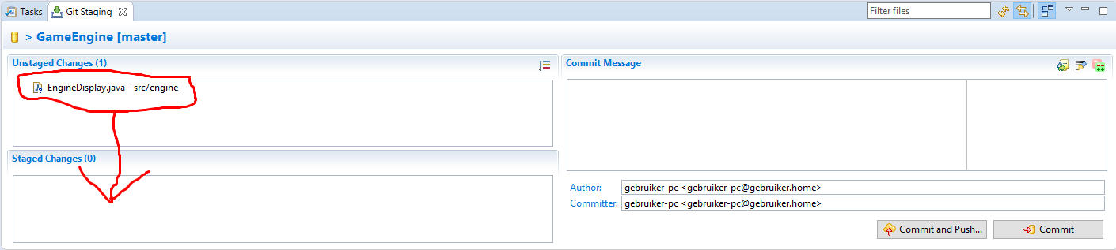

4: Add an commit and press commit and push

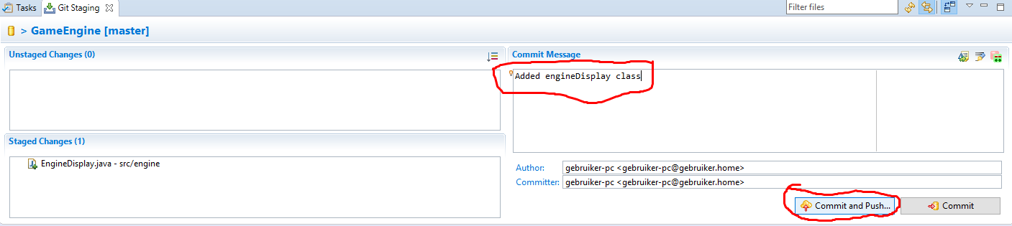

5: Ur done